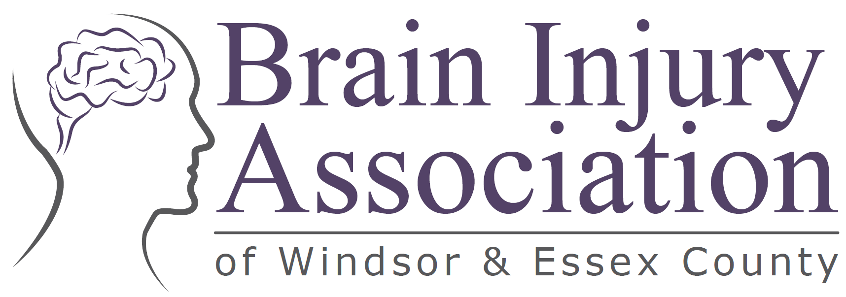

STRATEGIC PLAN 2025 – 2030

BIAWE maintains its steadfast commitment to those living with brain injury. Our dedication focuses on support, education and awareness to help others learn about the impact of brain injury on the survivor and their caregivers.

Some Facts about Acquired Brain Injury:
- More than 500,000 Ontarians are living with the effects of an acquired brain injury.
- 94% of individuals living with brain injuries reported they’ve experienced a mental health concern after their brain injury.
- 58% reported they’ve experienced more than one mental health condition since their brain injury.
- 78% of caregivers stated that their caregiving role impacted their own health and well-being.
- There are more than 190,000 documented concussions annually in Ontario.
- Of the three injury types, head injury or concussion had the highest weighted prevalence at 4.4% for children in Ontario ages 1 to 17 years.

Our Mission
The mission of the Brain Injury Association of Windsor and Essex County (BIAWE) is to enhance the lives of those affected by acquired brain injury through education, awareness and support.

Our Vision
BIAWE strives to provide education and awareness about brain injury within the community as well as to continuously evolve, learn and grow and be recognized as a leader for brain injury related programs in Windsor and Essex County.
Our Core Values and Principles
Respect, Support and Knowledge through Education and Awarenes

A Message From BIAWE’s Board of Directors and Executive Director

The Brain Injury Association of Windsor Essex (BIAWE) is proud to present its Strategic Plan for 2025 to 2030 – a comprehensive yet fluid framework that will guide our work and assist our Board over the coming years. This plan reflects BIAWE’s solid and unwavering commitment as outlined in BIAWE’s Mission, Vision and Core Values and Principles.

This strategic direction reaffirms BIAWE’s dedication to increased awareness, organizational sustainability, systemic advocacy, equity, diversity and inclusion. These priorities are essential to achieve our mission of enhancing the lives of Ontarians living with ABI through education, awareness and support.

Brain injury knowledge and information continues to evolve and BIAWE remains steadfast in its Mission. BIAWE’s Strategic Plan offers an opportunity to review our core values, principles and our vision and mission. This includes building upon a strong foundation within our community and other organizations to better assist the individuals and families living with brain injury.

BIAWE recognizes that all residents of Windsor-Essex, regardless of race, ethnicity, gender, sexual orientation, age or socioeconomic status, should have access to the support they need for a meaningful recovery after brain injury. This commitment is central to BIAWE in serving its clients and members.

With every strategic plan comes renewed focus. BIAWE is poised to strengthen its role as a leader in the Windsor Essex ABI community and to create lasting, meaningful changes for the people we serve.

Education and Awareness have always been the mainstay and focus for BIAWE’s existence. Our many programs and pilot projects that range from children to seniors on a variety of brain related subjects, provide support to and education for those living with brain injury. Our workshops, information sessions and annual conference educate the community and healthcare providers, while increasing awareness.

In short, BIAWE wants to make a difference to the community of Windsor Essex for those affected by acquired brain injury.

Sincerely,
BIAWE’s Executive Director
Rachel Olsen
BIAWE’s Executives
Alex Carson, Chair
Theresa Wunder, Co-Chair
Joanne King, Treasurer
Lauren Fields, Secretary

BIAWE’S Board of Directors
Dr. Marcus Niessen
Ann Marie Keough
Dr. Allison Kivisto
Danielle Ferri
Lauren Fields
Dominic Damas
Krystal Decker
Debbie Boose
Pam McCurdy
Krystal Decker
Joshawa Rupert
Dom Damas

PRIORITIES, GOALS, PLANS

PRIORITY #1 – INCREASED AWARENESS, EDUCATION & ADVOCACY

BIAWE understands that increasing the knowledge and awareness of BIAWE and our cause will advance the understanding of this disability that is frequently called an “invisible disability”. BIAWE intends to heighten awareness and education to reduce any misunderstanding or misconceptions about brain injury.

Strategies to Increase Awareness and Increase BIAWE’s Community presence:
- Coordinate local ABI initiatives
- Expand public education programs
- Launch awareness campaigns
- Expand BIAWE’s online presence and utilize social media to reach a broader audience
- Expand dissemination and knowledge exchange
- Strengthen existing partnerships
- Cultivate new partnerships and collaborative opportunities
- Proactively monitor trends and proposed policy development and changes
- Engage in public consultations and policy discussions to advocate for ABI interests.
- Establish and maintain strong stakeholder relationships.
- Foster and facilitate community engagement on ABI related issues

PRIORITY #2 – ORGANIZATION SUSTAINABILITY

BIAWE recognizes that financial stability and sustainability with commitment are fundamental to provide leadership and service delivery to enhance BIAWE’s ability to serve those living with brain injury within Windsor Essex.

BIAWE must continue to be a financially stable organization and maximize organizational efficiency, productivity and commitment.

Strategies to be financially stable and efficient are:
- Increase our sources of revenue through innovation and unflagging commitment
- Optimize operational efficiencies.
- Update strategies to engage in current fundraising efforts.
- Ensure excellence in organizational governance, management and service delivery
- Commit to ongoing professional development for the staff, volunteers and community associations.

PRIORITY #3: EQUITY, DIVERSITY and INCLUSION (EDI) and SUPPORT

Strategies to increase EDI practices:
- Sustain and improve EDI practices through a continuing, strong commitment across all organizational levels and activities.
- Ensuring that services, programs and workplace practices are designed to meet the diverse needs of all clients, staff and volunteers with a focus on EDI.
- Engage with diverse communities to gain insights into their unique perspectives and needs to integrate those insights into program planning, development and service delivery.
- Collaborate with cultural and community organizations to ensure that service delivery is culturally respectful and responsive to Ontario’s diverse populations.

PRIORITY #4: A SPACE OF OUR OWN

BIAWE’s 2025-2026 goal is to find an accessible space of our own so we can provide day programs for our clients, and offices for our Social Worker and Executive Director to meet with clients and conduct the day-to-day operations of our organization. This space will enhance our efficiency, productivity and ability to provide services to our clients and their families.

Making a Difference

BIAWE is committed to improving the quality of life for those affected by acquired brain injury in Windsor and Essex County. Our strategic plan is the foundation on which BIAWE’s decisions are made, resources are allocated and efforts are focused.

BIAWE is enthusiastic and invigorated by the implementation of our strategic priorities. We continue with our excitement to make an even greater difference in the lives of individuals and families who have been impacted by acquired brain injury.

It is BIAWE’s honour and privilege to do what we do and to grow, strategize, educate, and plan to help those who need our services.

*************

Mental Health Consequences of Traumatic Brain injury, J. Howlett et al, Biol Psychiatry 2022 Mar 1;91(5);413-420 and Mental health After TBI or Concussion: Recovery is Possible, A. Fong Cognitivefx July 16, 2024
This info was secured from OBIA’s Strategic Plan 2025-2030. Their statistics were sourced from OBIA’s Impact Student and the TBI Report Card from KITE UHN.
Public Health Ontario , Enhanced Epidemiological Summary Injuries among Children using the Canadian Health Survey on children and Youth, 2nd Edition, April 2024.

