Butterfly Lane Mural Project 2021
Your support helps to cover costs associated with this project which is intended to promote awareness of acquired brain injury and make visible the “invisible” disability association with a brain injury. The Butterfly Lane borders are: Devonshire/Argyle and Ontario/Richmond.
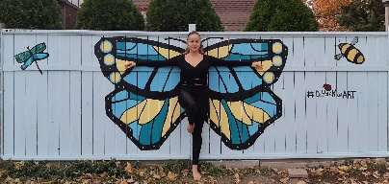

 | Butterfly  $2,000 | Chrysalis  $1,000 | Caterpillar  $500 | Eggs  $250 | Milkweed  $100
Logo on Mural | x
Sign next to Mural | x | x | x
Social Media on all Partners’ sites | x | x | x | x | x
BIAWE Newsletter | x | x | x | x | x
Website of all Partners | x | x | x
Acknowledgement at Public Events | x | x
Listed on Sign in Alley |  |  |  | x | x

Company/Organization Name:Click here to enter text.
Address including Postal Code:Click here to enter text.
Contact Person:Click here to enter text.
Email:Click here to enter text. Phone:Click here to enter text.
Sponsorship Level: Click here to enter text. OR: Donation Amount:Click here to enter text.
Payment amount: Click here to enter text.
Payment Method: PayPal ☐ Cheque ☐

Deadline Date to Register: August 9, 2021 (Payment due with registration). BIAWE - 519-981-1329
By Cheque Made out to: Brain Injury Association of Windsor and Essex County
Mail to: 856 Victor Dr. Windsor, ON N8S 2S7

Donations over $20 will be issued a tax receipt.

By PayPal: Go to www.biawe.com to pay AND email Registration Form to payment@biawe.com
Charitable Registration Number: 87686 5817RR0001

